# Description:

1. Let’s first understand different classpaths available during the build.
2. 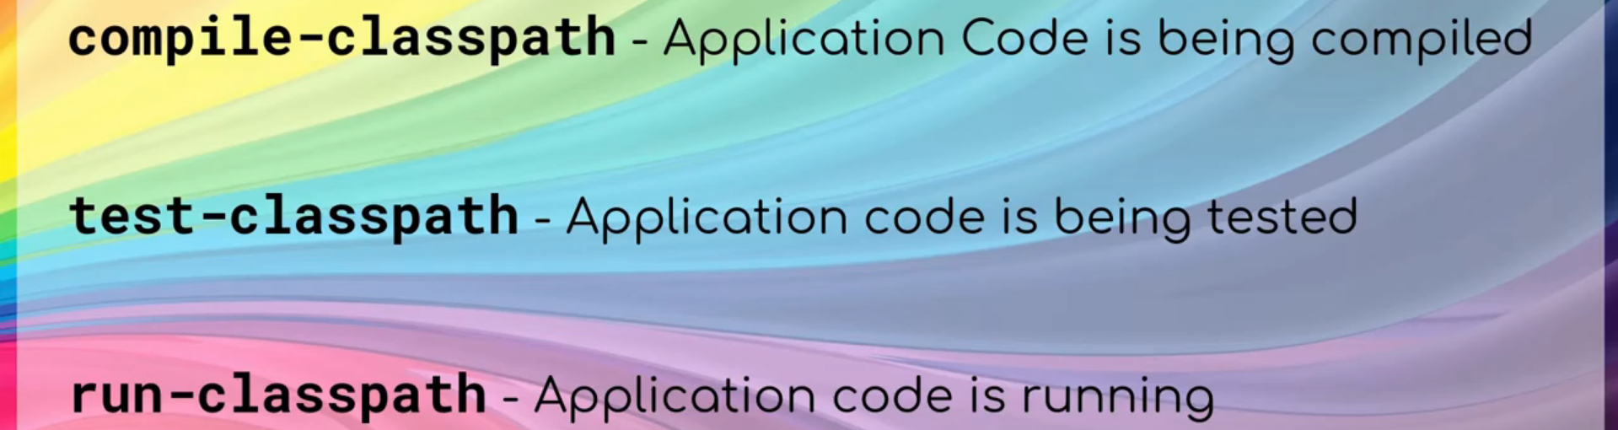
3. Let’s understand a bit more.
   1. In a typical maven project, two source folders.
   2. 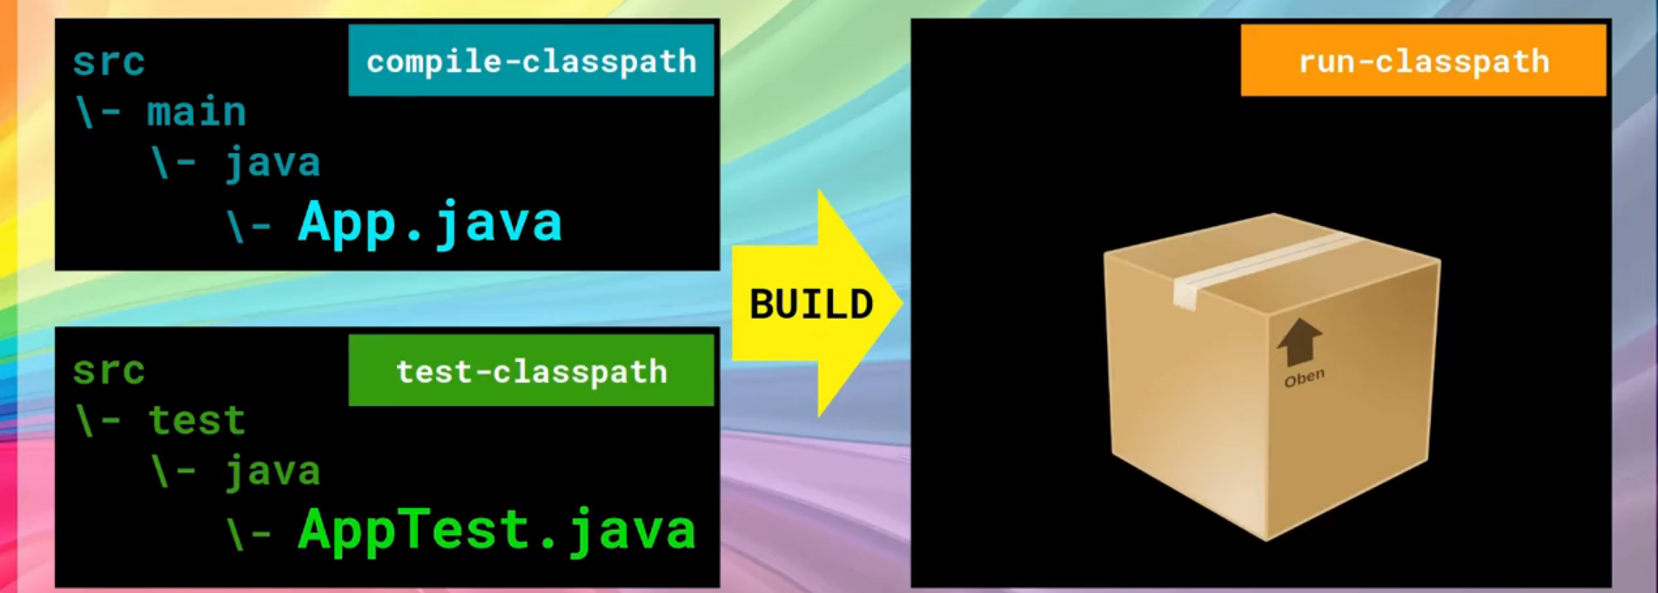
4. Total Scopes:  
   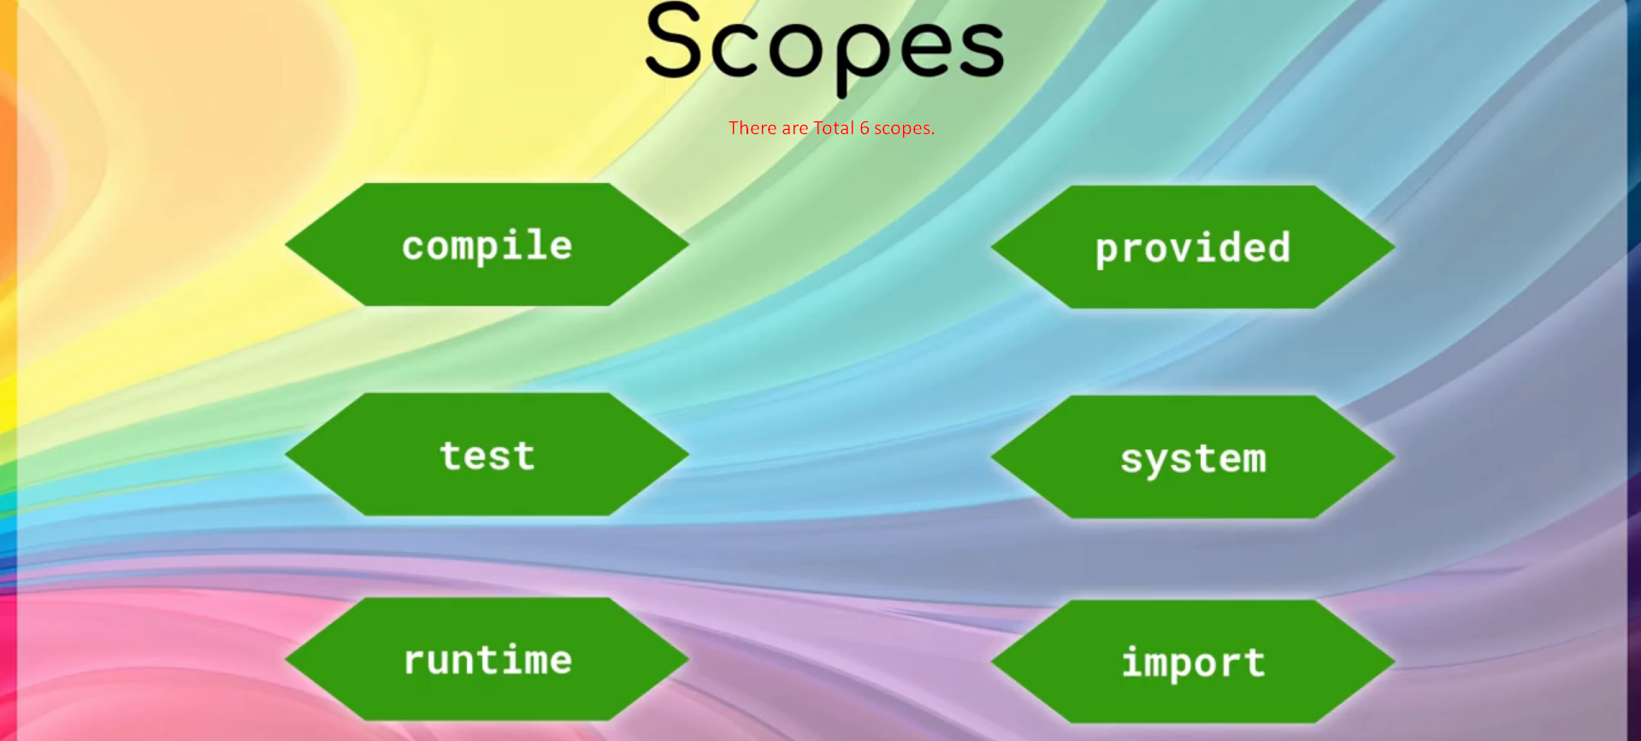

## Compile Scope

1. Default Scope.
2. Dependency with compile scope is available in all classpaths 🡺 compile, test and run.  
   It means that the dependency can be used in app code (compile), test code (test), and when your app is running (run).
3. 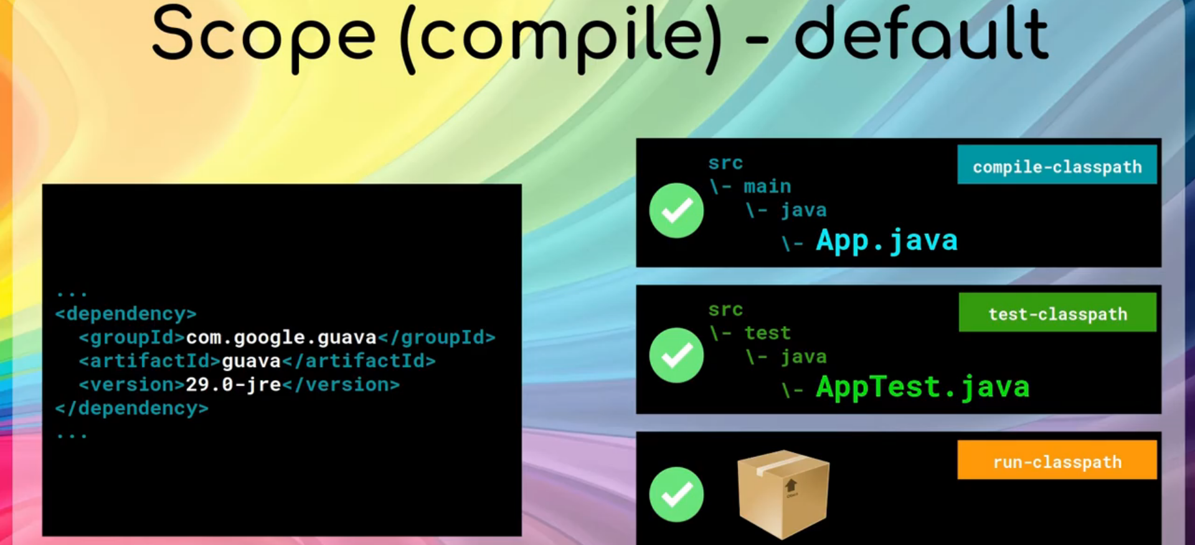

## Test Scope

1. 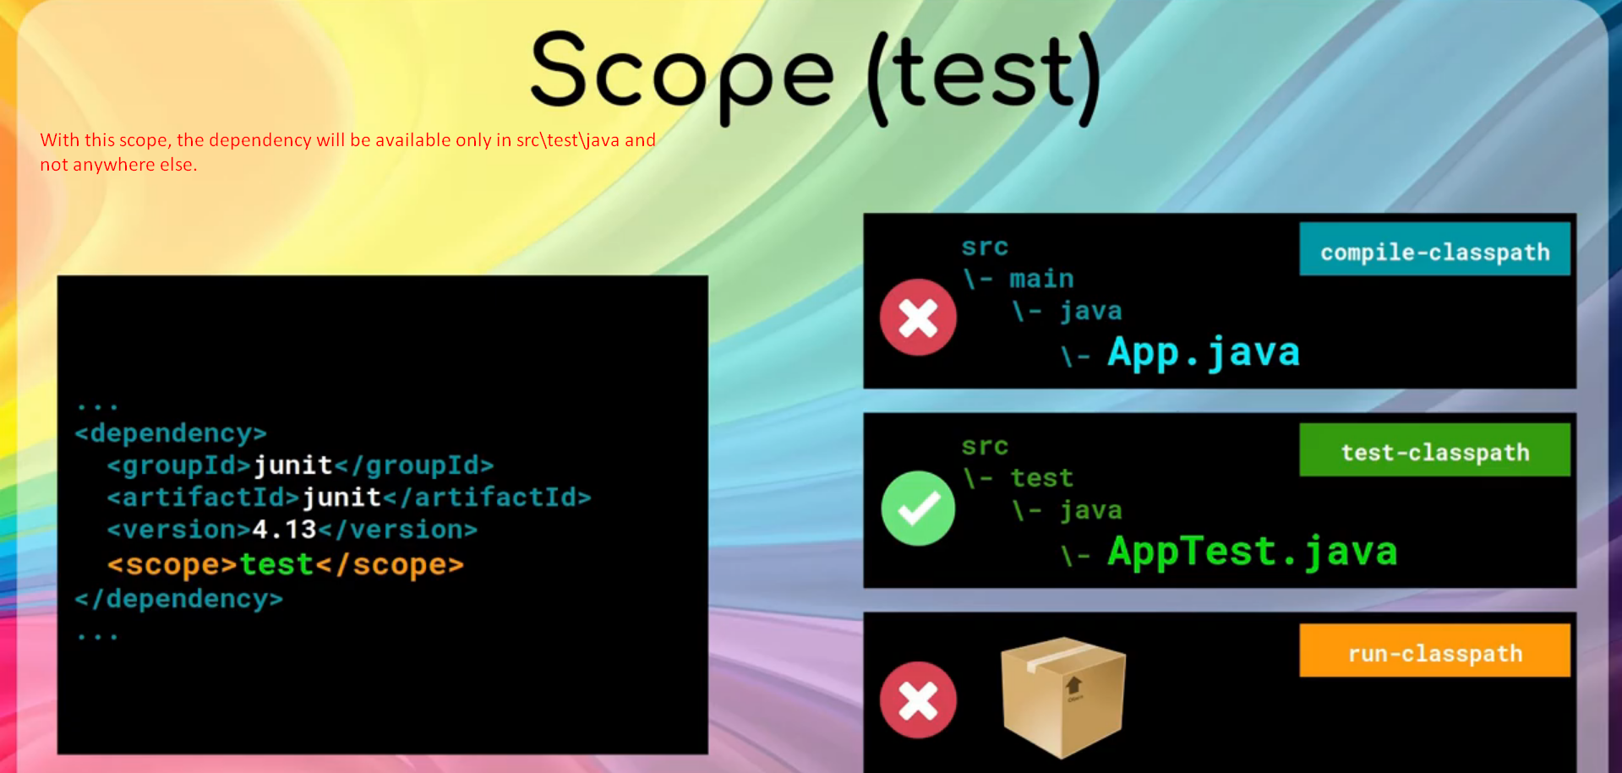

## Runtime Scope

1. Dependency available only under test-classpath and run-classpath means for test code and at runtime the dependency is available.
2. This scope is useful when you want to dynamically link a dependency and the dependency is not directly used in your app source code.
3. **Example**: JDBC Driver.  
   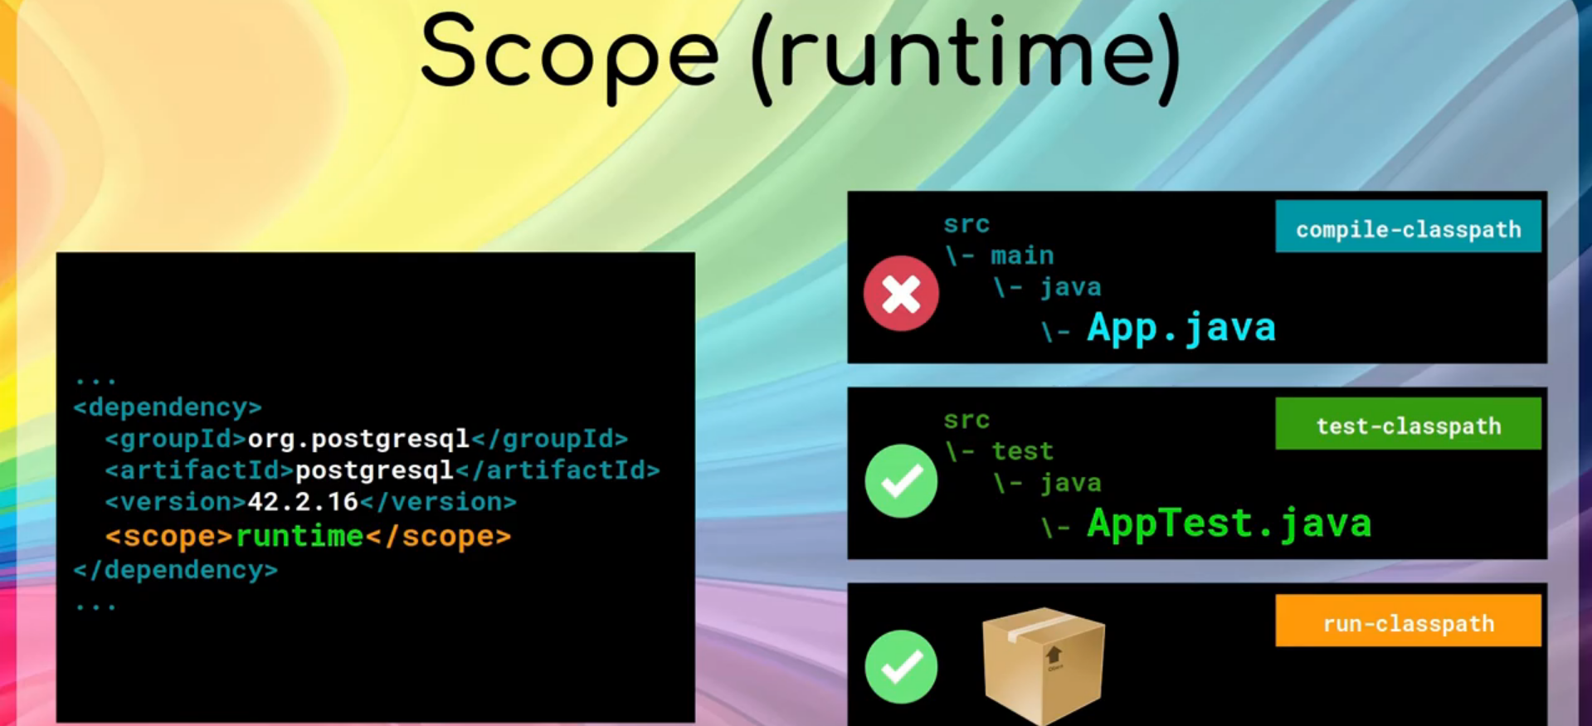

## Provided Scope

1. This scope is very similar to compile except that it expects the environment (where you run the app) to have already this dependency.  
   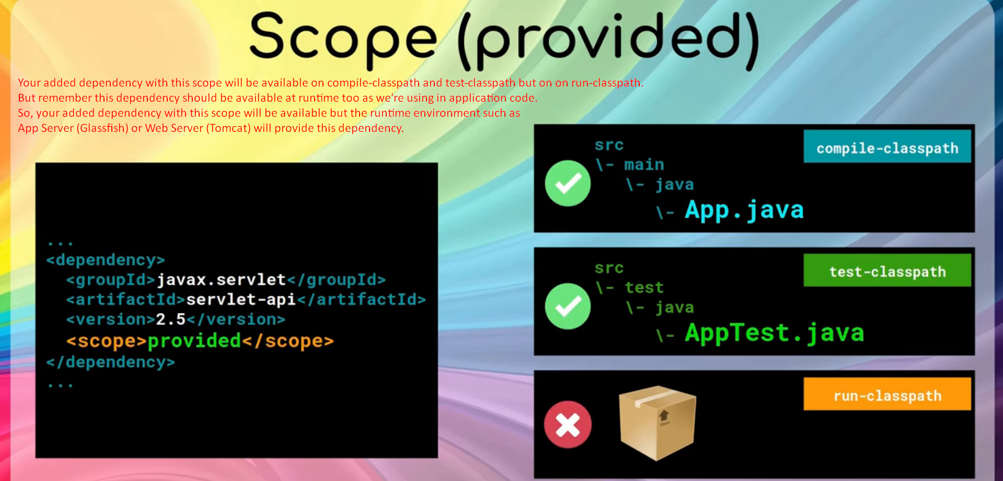
2. 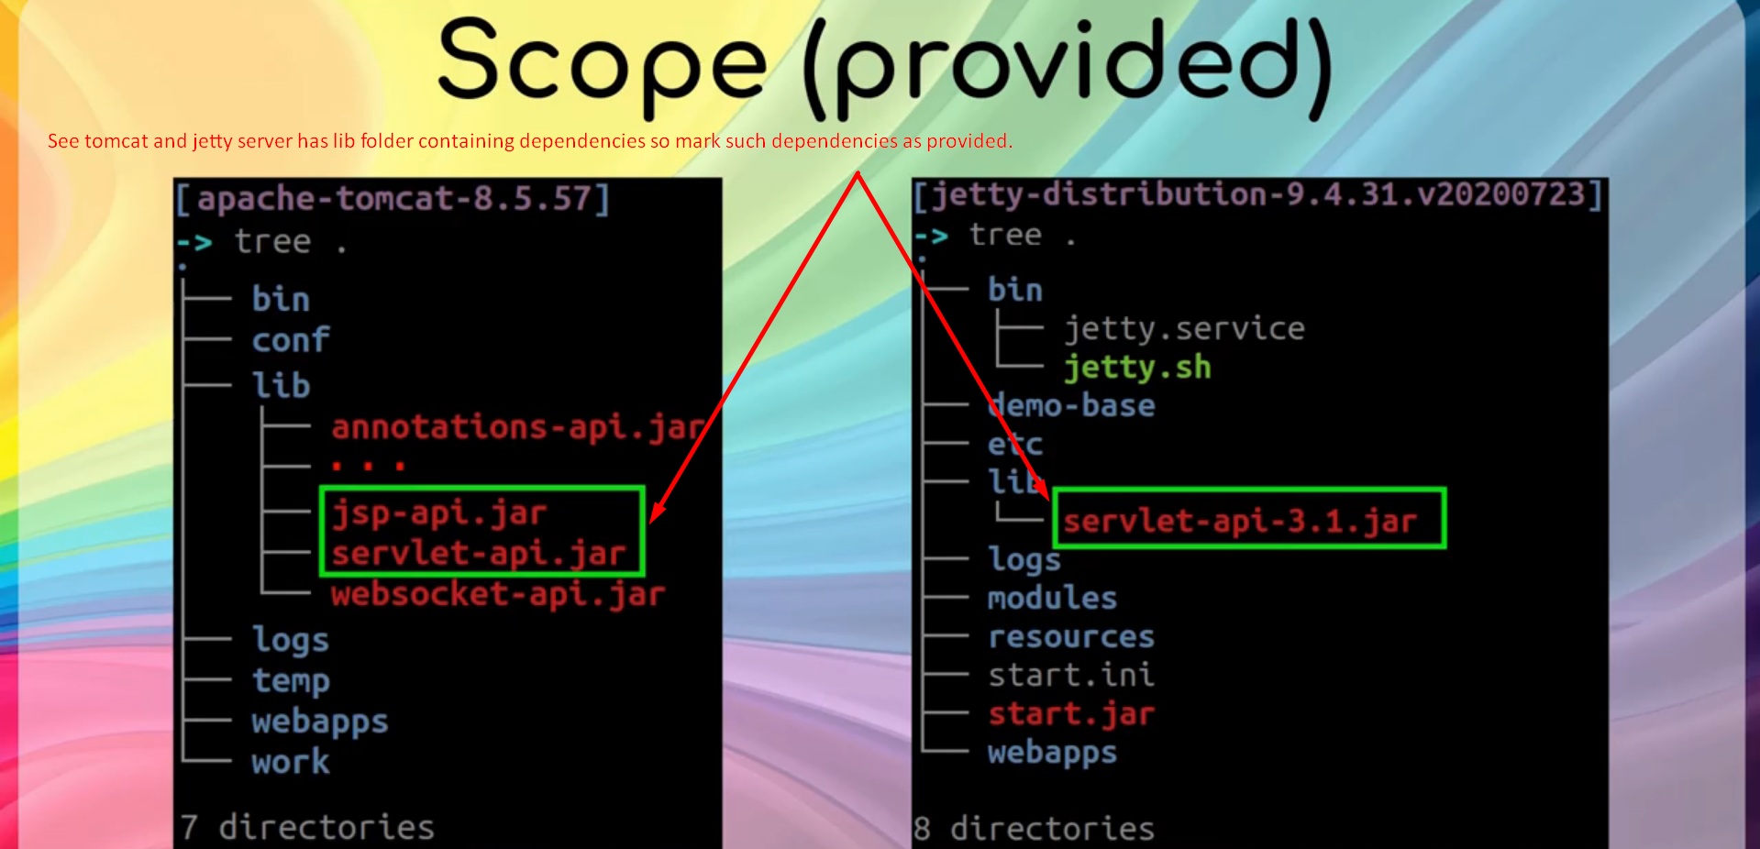

## System Scope

1. 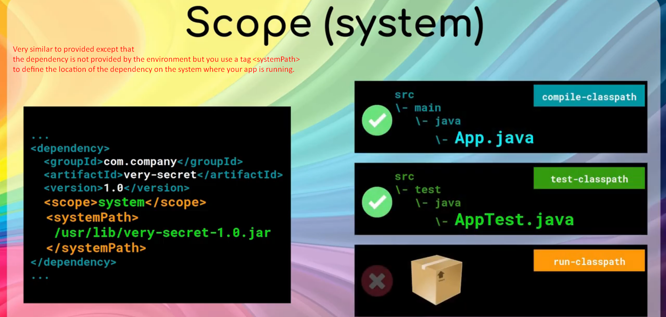

|  |  |
| --- | --- |
| Provided Scope | System Scope |
| The dependency will be provided by the runtime environment such as Tomcat, Jetty, Glassfish etc. | The dependency’s location will be specified by you on the runtime environment. |
| The dependency will be available at compile time and test time (means in app code and test code) but will not be included in the packaged jar file when building app. | Same. |

## Import Scope

1. It is a bit different from other scope.
2. It is part of dependency management section <dependencymanagement>
3. This is useful when you want a consistent set of dependencies that is used in a team or organization.  
   